Level 0 -> Level 1

The goal of this level is to find the pass to log into <http://natas1.natas.labs.overthewire.org>.

Username: natas1

After logging into level 0 we got a hint to get the password of next level. The hint is “**You can find the password for the next level on this page.”**

We may try to find something inside the source code. To view source code, we will right click on the webpage and select ‘View Page Source’.

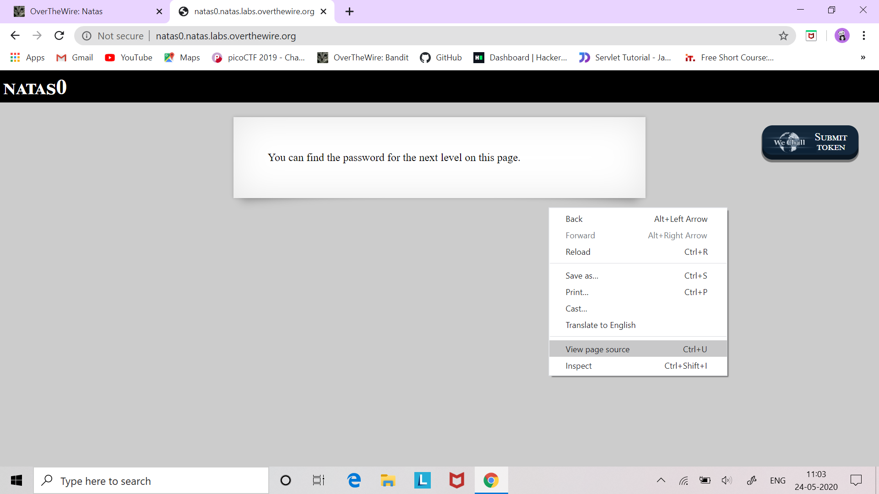

And there is the password commented in our source code.

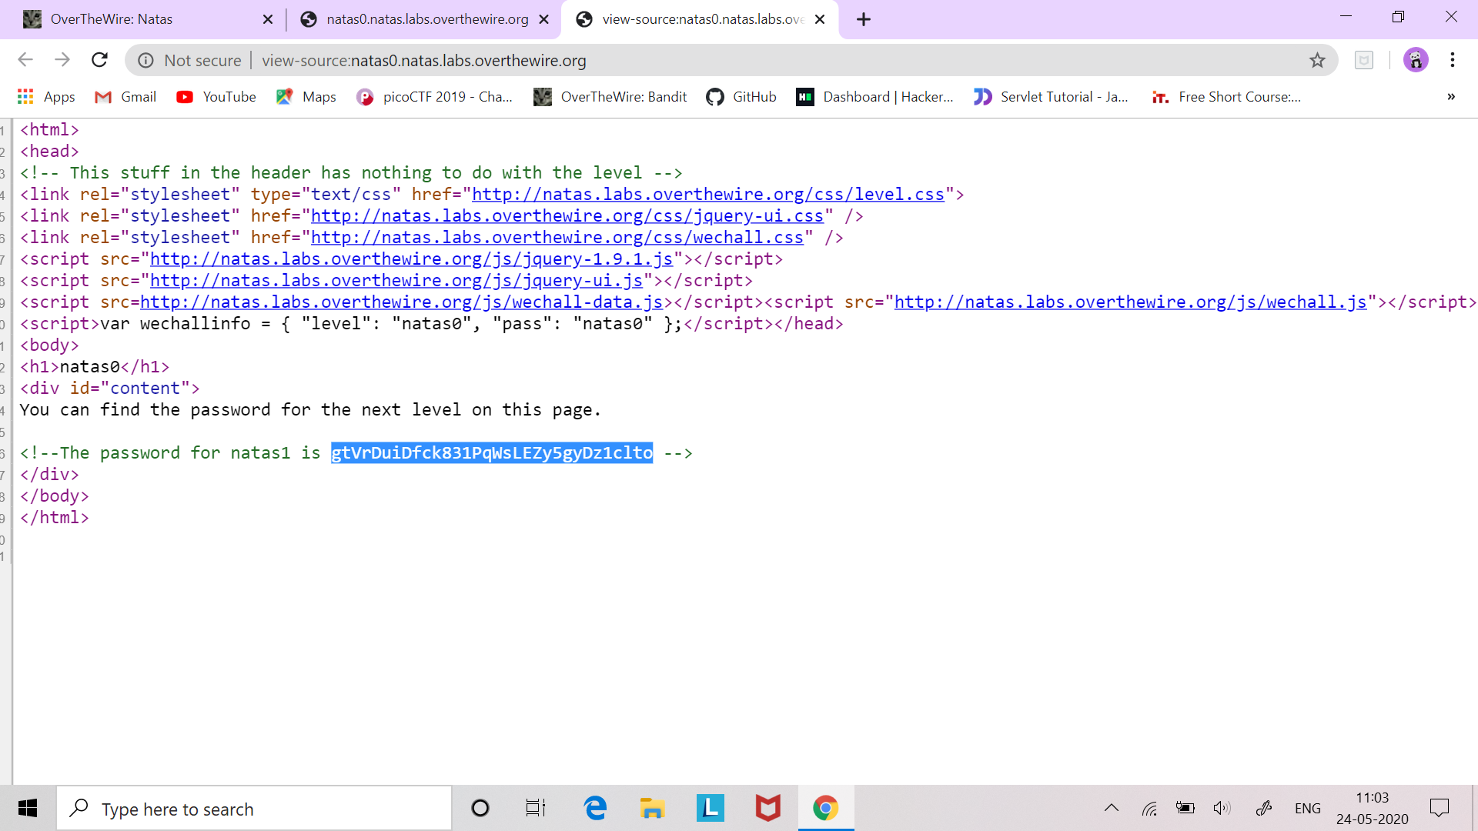

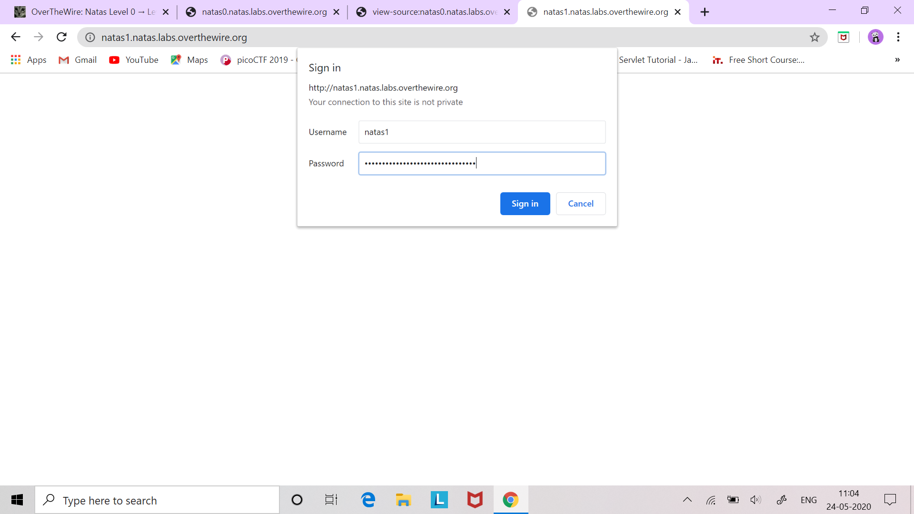

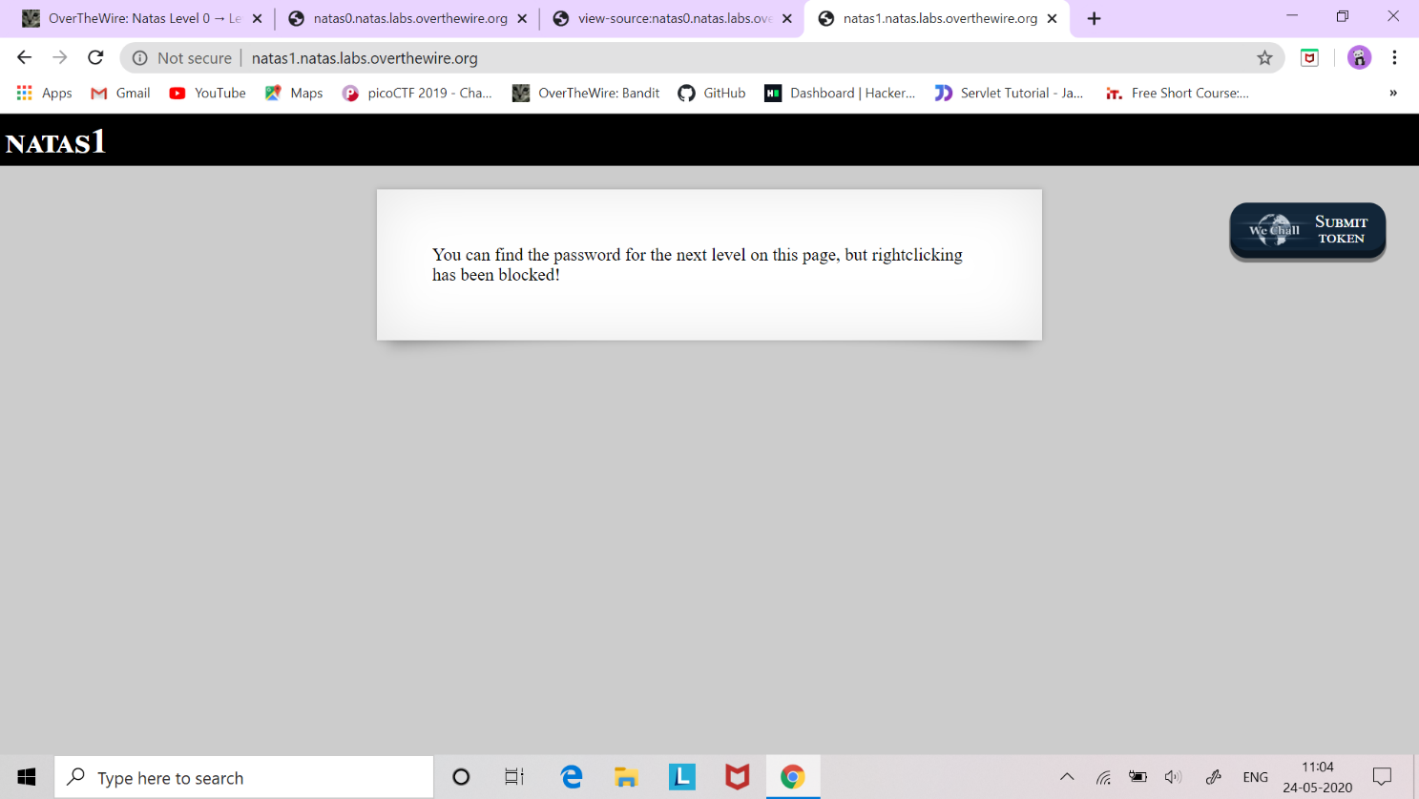

Successfully passed level1.…